SPARK: Simple Play Adaptations to Reference for Kids

Quick Activity Strip Display System
Description: | Image:
The Quick Activity Strip Display System comes with six 2-sided picture display loop fabric strips for quick change of communication pictures, or schedules. A thick plastic 16” x 4” display board has a hook strip to use with the loop fabric strips. Place pictures on loop fabric strips and attach to the display board (Prearrange loop fabric strips for speedy change of activity). A carrier with zipper and handle holds display board and activity strips. | 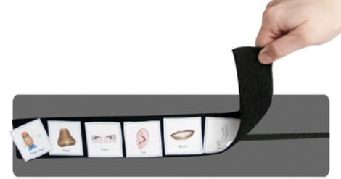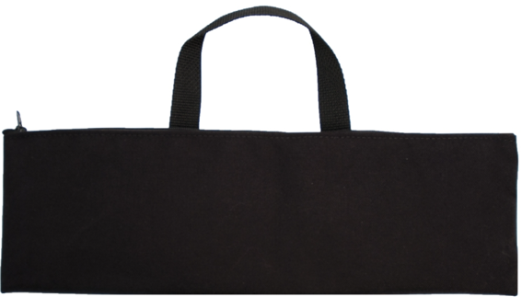  Purchasing Information

Who Might Benefit?
Those who…
• Are transitioning from single words to forming simple sentences.
• Are working on independently following single step directions.
• Need help “pacing” their words.
Why Use?
Provides an opportunity to…
• Expand communication from single words to simple sentences.
• Follow single sentence directions.
• Visualize the language they are speaking and hearing.
• “Pace” the words they are speaking.
• Follow a picture schedule.
Instructions for Use: | Adaptation Ideas:
Environmental Considerations  - Easily use in almost any environment because of the small size, weight, and easy transportability.  - If this particular style of communication is selected, make sure it is available is all child’s customary environments (e.g. home and school) to provide structure and routine, improve understanding, avoid frustration and offer opportunities to interact with others.  Positioning  - Use in most any position due to the size, portability, and minimal weight. It can be used on a table top, placed on the floor, positioned on a slant board, etc. A child could use it in positions such as sitting, standing, prone (Tummy Time position), supine (laying on their back), kneeling, etc. Provide at optimal viewing level and ensure its within reach of the child.  Alternate Positioning  - Place on cover of a 3” three ring binder with Velrco.  Basic Play/Use  - Introduce Activity Strip(s) with added symbol/visual support pages to the child and explain what you are going to be using it for.  - Be consistent in the use of visuals.  - Make accessible to everyone supporting the child (e.g. have a specific area for keeping it) and make sure everyone knows where it is.  Extended Play/Use  - Model use of the activity strips with pointing. | Optional Additional Materials/Supplies  - Velcro  - Cardboard  - Duct tape  Build It Up  - Build up boards for easy gripping or to provide high contrast.  Simplify It  - Start with only a few photos or visual symbols on each page based on the child's ability to understand and select responses, adding more as needed.  Stabilize It  - Velcro to various surfaces in the environment as needed so it does not shift while the child is attempting to access it.  Add Sensory Cues  - Place small dots of puff paint, stick on jewels, or adhesive backed fun foam dots at the base of each word or symbol as a tactile guide to “pace” words or symbols as they are pointed to or verbalized  Alternative Uses  - Insert series of sentence strips in pocket charts to form simple stories  DIY Alternatives  - Add loop Velcro to jumbo craft sticks or paint stirrers to form surface of sentence strip, then use with object, photos, or visuals.  - Cut piece of cardboard into desired length, cover with duct tape, and add loop Velcro. Use with objects, photos, or visuals  - Dollar Tree stores sometimes carry pocket charts as a low-cost display alternative for multi-step schedules, a series of sentences, or retelling a story.

Resources:
- Look for free examples of sentence strips on sites such as TPT.
- How to create low tech communication pictures
- Examples of good high contrast color schemes for low vision and why they are important

Note: Research has shown that early use of a communication device does not impact a child’s ability to develop oral speech later and will actually often help to enhance development of oral speech. See: Beyond Spoken Words :Augmentative and Alternative Communication (AAC).

